INVENTING TOMORROW:
Video Streaming and the Future of OTT Television Services
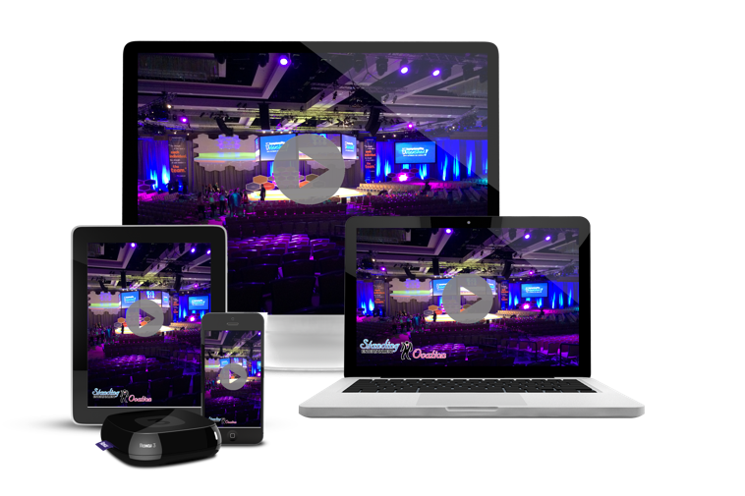

We are living in a transitional time in the video industry where the business of television
is being redefined. The traditional television players, including broadcasters, cable operators, satellite television distributors and program producers have steadily transitioned into
a new class of hybrid-media companies capable of designing both television programs as well
as engaging in the video streaming of programs to the end user. The term video streaming
refers to a type of media in which information and entertainment is continuously delivered
via the Internet to a remote user. Central to the discussion is the future of over-the-top (OTT)
video services; that is, television and film programming that can be streamed via the Internet
to residential dwellings equipped with high-definition television sets as well as those who use various kinds of mobile devices including smart-phones, tablets and personal computers. Examples of OTT video streaming services include: Netflix, Amazon Prime, HBO Max, Disney+
and You Tube to name only a few. OTT represents the principle of video-on-demand made practical.

This presentation looks at some of the critical issues related to the future of video streaming technology and over-the-top (OTT) television services in particular. The development of OTT
will continue to disrupt the broadcast, cable television and TV/film production studios in fundamental ways. Several of the major U.S. television networks have steadily expanded into over-the-top (OTT) streaming services like the Walt Disney Company’s Disney+ and Hulu,
NBC’s Peacock and CBS’s Paramount+ as a strategic hedge against the decline of traditional broadcast and cable TV. This shift reflects both market pressures and opportunities in how audiences consume video today.
Such companies recognize that audiences are shifting away from traditional TV viewing.
Many of today’s younger television viewers are increasingly “cutting the cord” on traditional broadcast and cable subscriptions in favor of streaming platforms accessible on phones, smart TVs, and tablets. The Networks realize that their future audiences may no longer rely on scheduled programming, so launching OTT services lets them retain relevance and reach viewers where they are. In addition, by offering streaming services directly, the major U.S. television networks can generate revenue in multiple ways, including: Subscription fees (SVOD), Advertising revenue (AVOD)as well as Hybrid models that mix ads and paid tiers.
This diversifies their income beyond the traditional advertising model more typically associated with broadcast television and the corresponding ratings structure. Advertising dollars are steadily shifting toward digital platforms that provide better audience targeting and data analytics.
OTT video streaming services will require a new kind of business model that will involve
a major rethinking of television in terms of program content, organization, financing and distribution.

